1. **Installing chocolately:-**

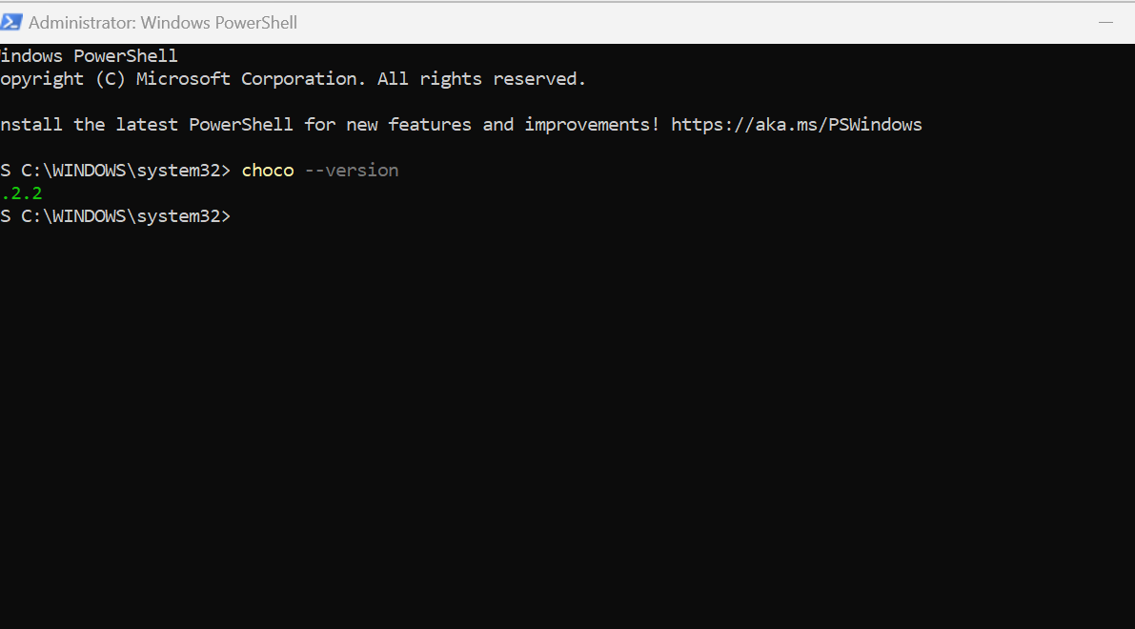

1. **Installing Git Client :  
   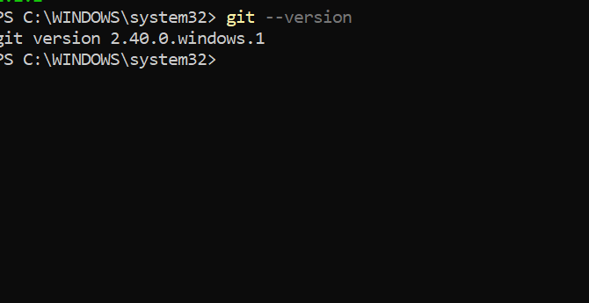**
2. **Virtual box**

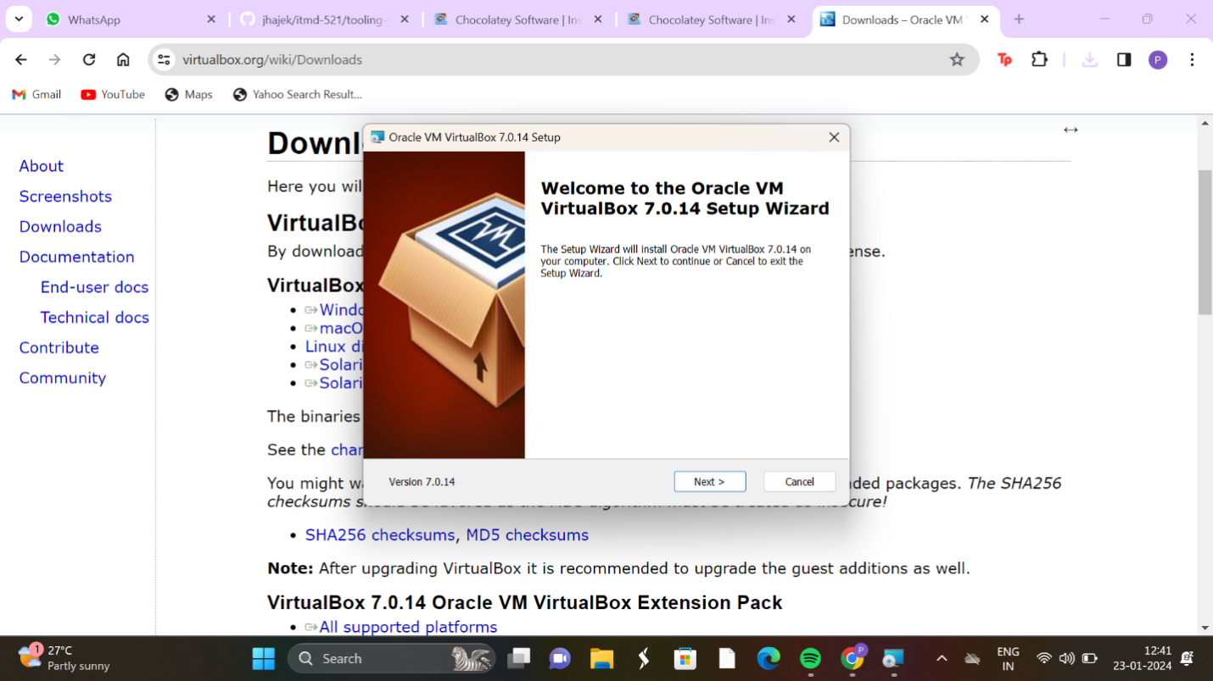

1. **Installing vagrant:  
   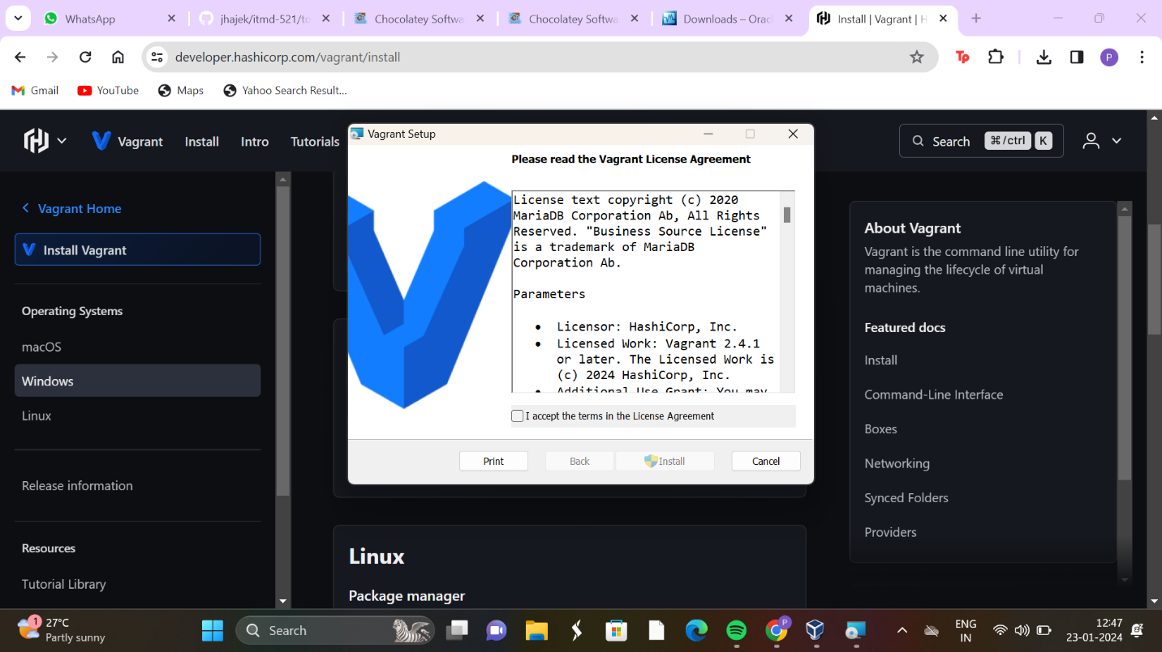**

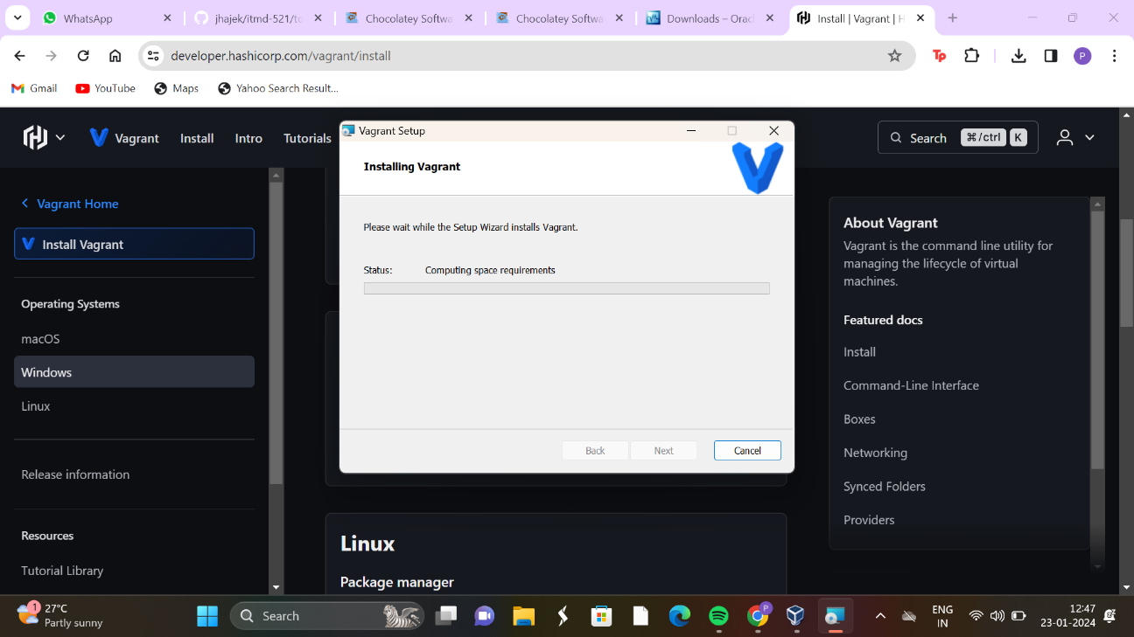

**Tooling Assignment Part II**

**Cloning the github repository**

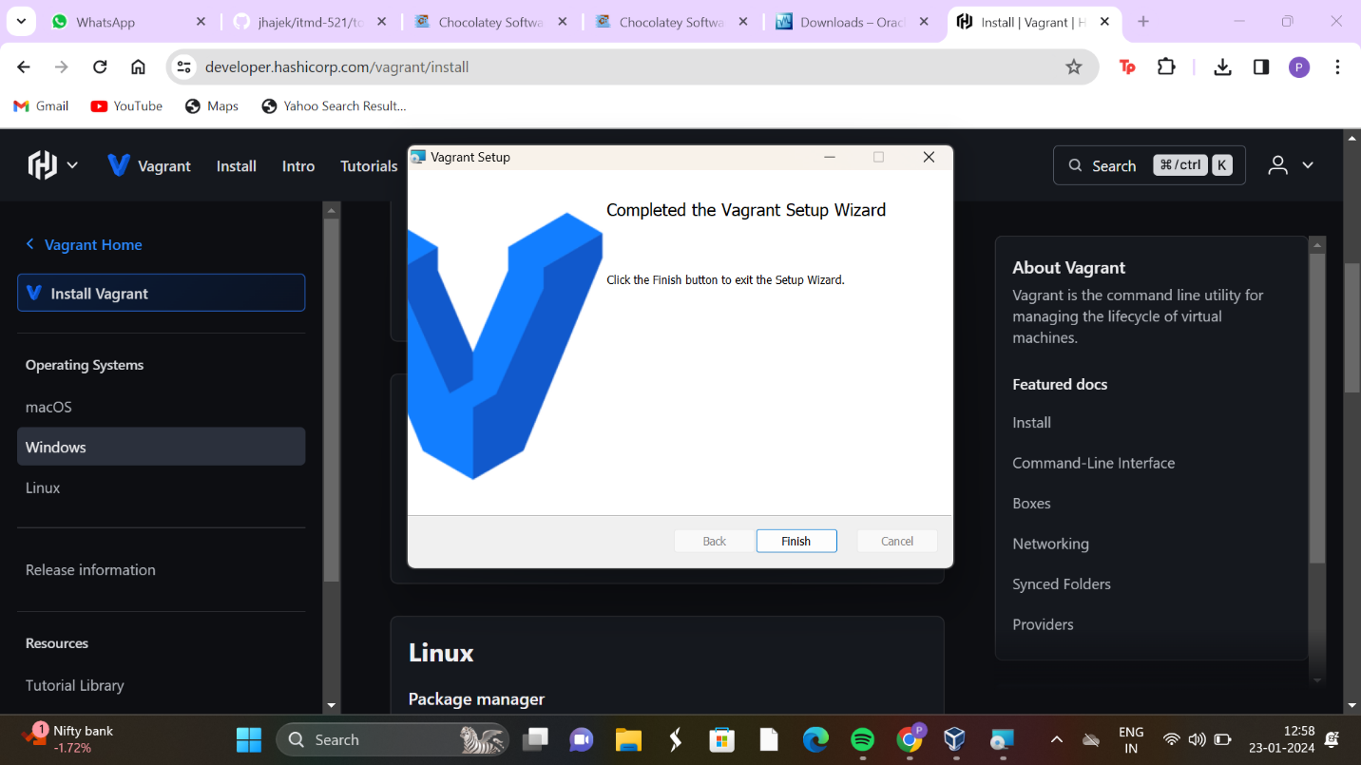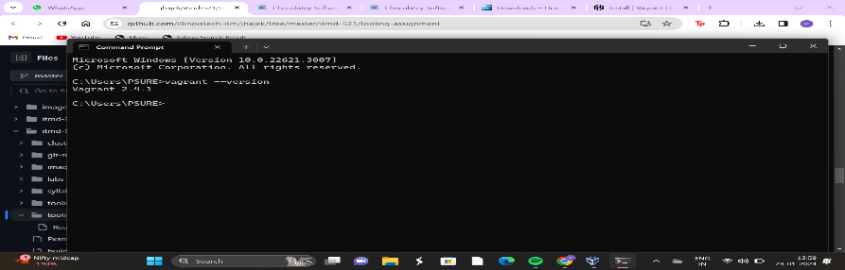

1. **Installing packer**

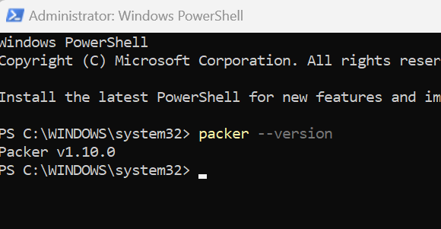

1. **Oh-My-Git Tutorial**

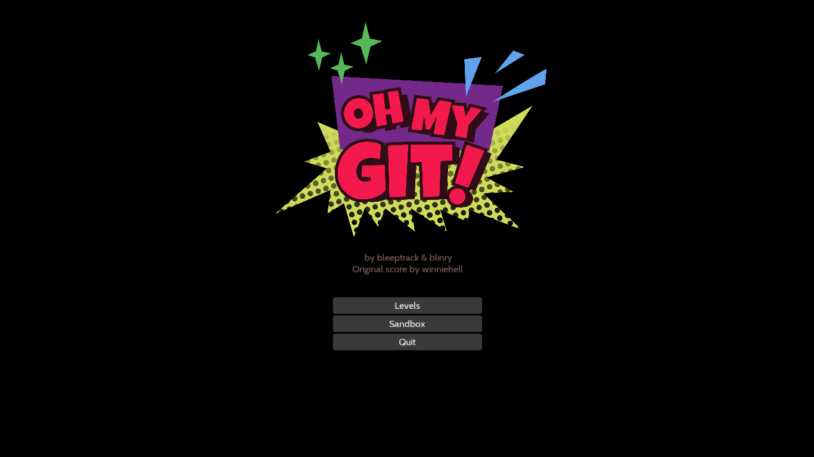

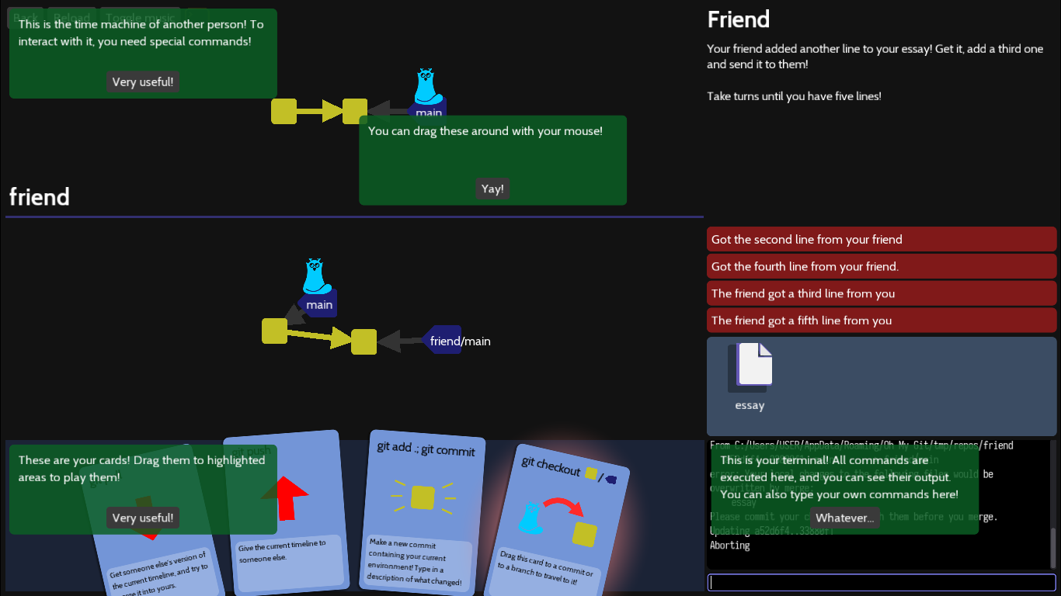

**Part II: Tooling assignment**

**Url: https://github.com/PRojitha/Projitha99/blob/main/README.md**